
Test paper B

Examination of Fundamental Physics

Major

Class No.

Name
Student No.

Number  of  problem | Ⅰ | Ⅱ | Ⅲ | Total score
Score

Ⅰ. Single choice questions (6 questions in total, 30 marks
Marks for Ⅰ
in total)

1. (5 marks)
The curling pot is sliding on the ice. If the external force on the curling pot disappears at the same time, it will
(A) Move in uniform rectilinear motion.
(B) Change the original direction of motion.
(C) Accelerate.
(D) Stop immediately.
[ ]
2. (5 marks)
As shown in Figure 1, under the action of two forces of 2N horizontally to the left and 10N horizontally to the right, an object moves in uniform rectilinear motion in the horizontal direction to the right, Please analyze the friction between the object and the ground:
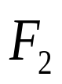
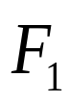
(A) Direction left, size 8 N
图1
(B) Direction left, size 12 N
(C) Direction right, size 8 N
(D) Direction right, size 12 N
[ ]
3. (5 marks)
If an object with a mass of 1kg is placed on a smooth slope with an inclination of 30 ° and starts to slide from rest, the distance that the object passes along the slope in 3 seconds is (g is 10.0 m/s²):
(A)7.5m (B) 22.5m
(C)15.0m (D) 30m
[ ]
4. (5 marks)
A steel ball with a mass of 9kg moves horizontally to the right at a speed of 21.6km/h, and its momentum is:
(A)54 kg·m/s (B) 108kg·m/s
(C)97kg·m/s (D) 194kg·m/s
[ ]
5. (5 marks)
The hand press type flashlight can make the flashlight light up by pressing the handle, and the coil inside the flashlight makes the cutter sense line movement. What principle does this power generation use?
(A) point discharge (B) Electromagnetic induction
(C) Triboelectrification (D) Current thermal effect
[ ]
6. (5marks)
As shown in the figure, there are four experiments of electricity and magnetism. Which of them applies the working principle of the generator?

(A) 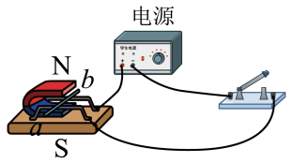 (B) 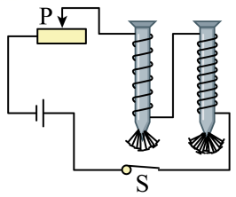
(C) 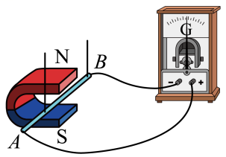 (D) 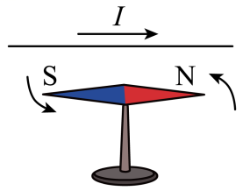
[ ]

Marks for Ⅱ
Ⅱ. Answer the questions with your concise wordsand/or
clear sketches (totally 5 questions, 40 marks in total)

1. (8marks)

(1) (5marks)As shown in the figure, object A is connected with the spring and is still on a smooth slope. Please draw the force diagram of object A.

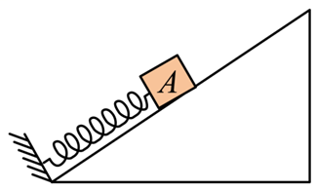

2. (8 marks)
A ball is thrown vertically up, its speed slowing under the influence of gravity. When we observe the motion of the ball from a frame of reference moving up at the initial speed of the ball, does the ball still have a downward gravitational acceleration g? Provide an explanation.

3. (8 marks)
In 2.5s,a car increases its speed from 60km/h to 65km/h while a bicycle goes from rest to 5km/h.which undergoes the greatest acceleration?what is the acceleration of each.

4. (8 marks)

Suppose a ping-pong ball and a bowling ball are rolling toward you. Both have the same momentum, and you exert the same force to stop each. How do the time intervals to stop them compare?

5. (8 marks)
In the corresponding brackets in the figure, mark the "N" or "S" poles of the permanent magnet and the "+" or "-" poles of the power supply.

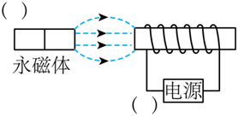

Marks for Ⅲ
Ⅲ. Calculations (3 problems, 30 marks in total)

1. (10 marks)

A system initially at rest has a constant total force of magnitude 295N on it. After 3.00s the speed of the system is 15.0m/s. What is the mass of the system?

2. (10marks)

As shown in the figure, the object with a mass of m=2kg was originally stationary on the horizontal ground, and the dynamic friction factor between it and the ground isμ= 0.4 , a constant force F = 12N in the horizontal direction acts on the object, g is 10m/s².

(a) (4marks)What is the acceleration of the object?

(b) (3marks)What is the displacement of the object within 3s after it starts to move?

(c) (3marks)What is the speed of the object at the end of 3s after it starts to move?

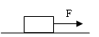

3. (10 marks)

In the circuit as shown in the figure, the voltage at both ends of the power supply is 4V and remains unchanged, and the resistance value of resistor R₁ is 10 Ω. After closing the switch S, the reading of the ammeter is 0.5A.

(a)Find the current I₁ passing through the resistor R₁;

(b)What is the resistance value of resistor R₂.

